Calumet County Swine Procedure
Step 1: On the picture card write the Tag Number, Ear Notches (if present), Family Name.
Step 2: Tag the Pig - disinfecting the tagger in-between each use.
Step 3: Take a digital photo of the pig, while holding the picture card so the image legibly contains the information on the card, the pig, and the tag.
Johnson
Legible card and ear tag number
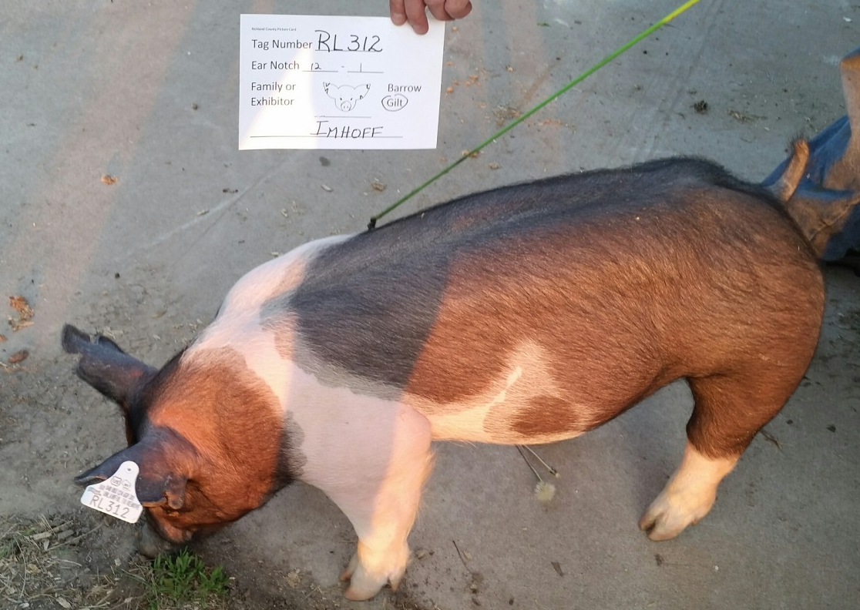
Step 4: Clean and disinfect the tagger.
Step 5: Send the digital photos to Janice Thiel (electronic format i.e. e-mail, cd, flash drive, SD card etc.). Send RFID Tag and Identification Form to Janice Thiel, may be mailed or e-mailed. Do not send more than three photos in an e-mail.
Step 6: You will receive a confirmation of the photos. If you don’t receive a confirmation e-mail within a day, please follow up, as it hasn’t received it.

Photos can be sent via email to calumetmarketanimal@gmail.com, please use the subject line: Market Animal Identification. If mailing, send to Janice Thiel, W2938 County Road B, Hilbert, WI 54129

ALL identification photos and RFID Tag and Identification Form must be mailed/e-mailed no later than MAY 15.

